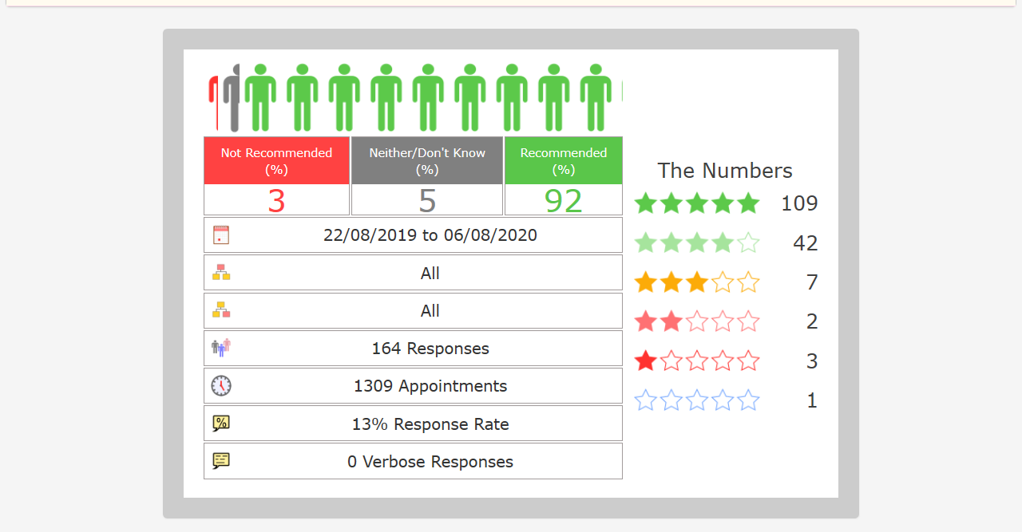
FRIENDS AND FAMILY RESULTS - SUMMER 2020

